**Ulises Cabrera González-A01730893**

**PRACTICA 2**

MULTIPLEXOR 4X1

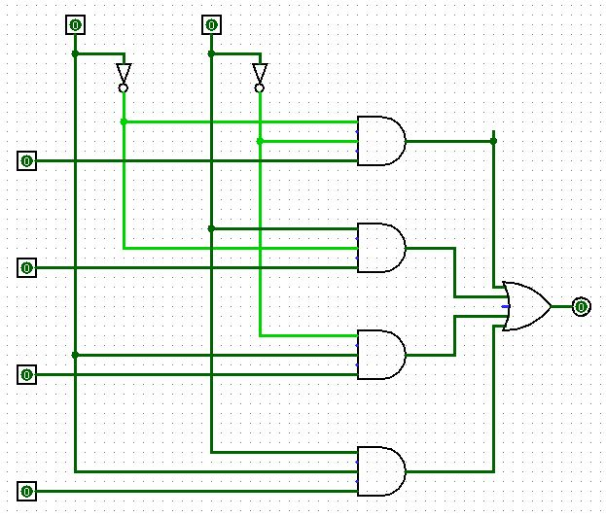

FULL ADDER

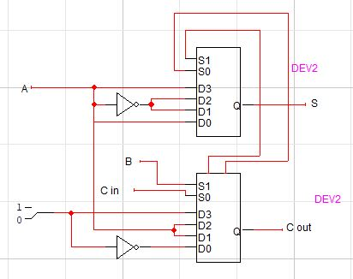

HALF ADDER

